Chapter 7, Solution 83.

Solving for t gives
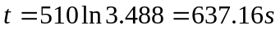

speed = 4000m/637.16s = 6.278m/s

